Pasts Mozello Module Installation Instructions

# Module Functionality

* Postal delivery to post offices in Latvia and Lithuania.
* Postal delivery to Pasts parcel lockers in Latvia and Lithuania.
* Postal delivery by Pasts courier both in Latvia and abroad.
* Letter and parcel post deliveries domestically and abroad.
* Option to print postal labels directly from the e-store administrator environment.

# Pasts Modules Installation

1. Contact Pasts to connect the API services: [uznemumiem@pasts.lv](mailto:uznemumiem@pasts.lv)
2. On your Mozello website -> Settings -> General settings -> Store settings -> Delivery
   1. Add delivery methods, where you need to specify the Name, service provider and delivery fee
   2. Integrations – enter the API keys provided by Pasts representative

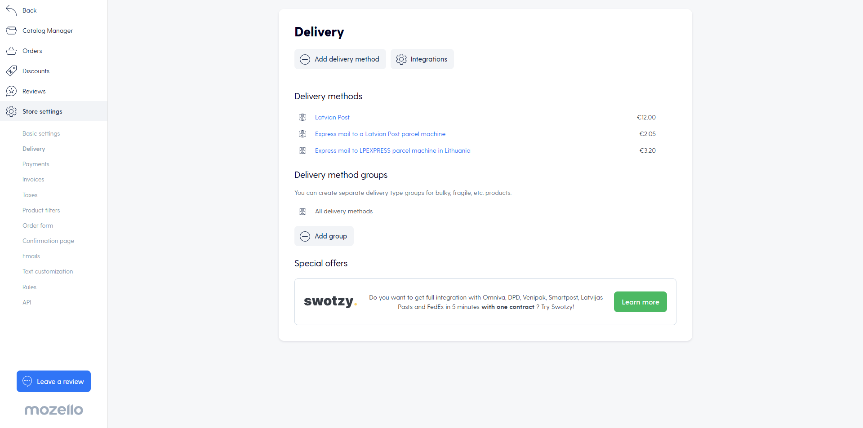

# Order Processing

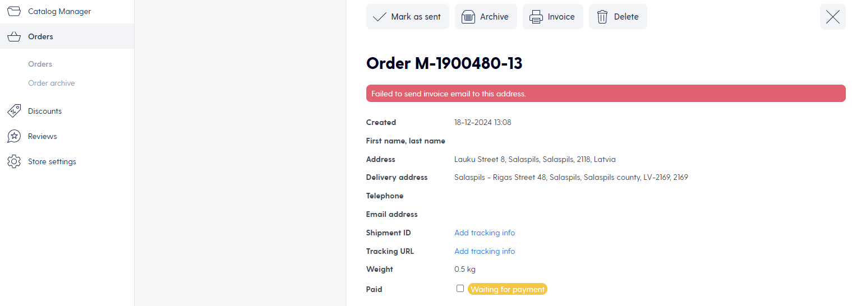

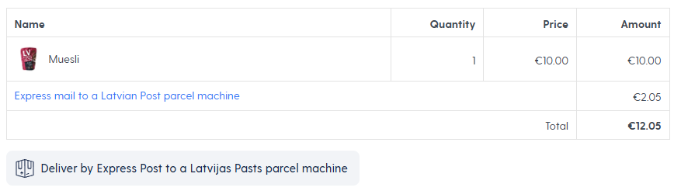

Deliver with [depending on the selected type] -> The information is forwarded to the Pasts system

After that, it is possible to print the postal label or cancel the delivery.

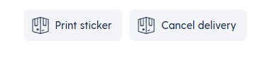

Courier requests and manifest generation are currently available in the Mans Pasts and Express Pasts systems.