**Pasts Opencart 2.3.x Module Installation Instructions**

# **Module Functionality**

* Postal delivery to post offices in Latvia and Lithuania.
* Postal delivery to parcel lockers (terminals) in Latvia, Lithuania and Estonia.
* Postal delivery by Pasts courier delivery both in Latvia and abroad.
* Letter and parcel post deliveries domestically and abroad.
* Option to print postal labels directly from the e-store administrator environment.
* Option to call a courier directly from the e-store administrator environment for handing over postal items.

# **Terms and Concepts Used**

Root directory — the main directory of the FTP server where all your website files are stored, usually www or public_html.

COD — cash-on-delivery service.

# **E-store Requirements**

The module is compatible with Opencart 2.3.x versions.

# **Server Requirements**

The module is compatible with PHP 5.6 and later versions. Before installation, find out if PHP 5.6 or a later version has been installed on the server.

# **Necessary Tools**

To add the Pasts module, a tool will be required to connect to the FTP client. To connect to the FTP client, you can use the following tools or choose another tool you are familiar with:  
FileZilla Client <https://filezilla-project.org>

WinSCP <https://winscp.net/eng/download.php>

Cyberduck <https://cyberduck.io>

# **Pasts Module Installation**

1. Create an empty folder and export the module files to that folder.
2. Connect to your FTP client using one of the tools specified above.
3. Drag the expanded folders in the Opencart systems into the web folder (files containing catalog, admin, system, image).

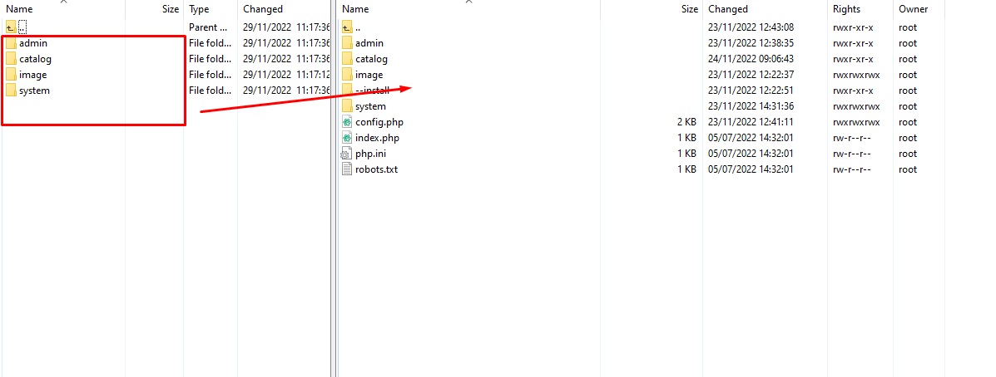

1. Log into the e-store administrator environment and go to Extensions >> Extensions >> Modifications. Then click the “Refresh” button.  
   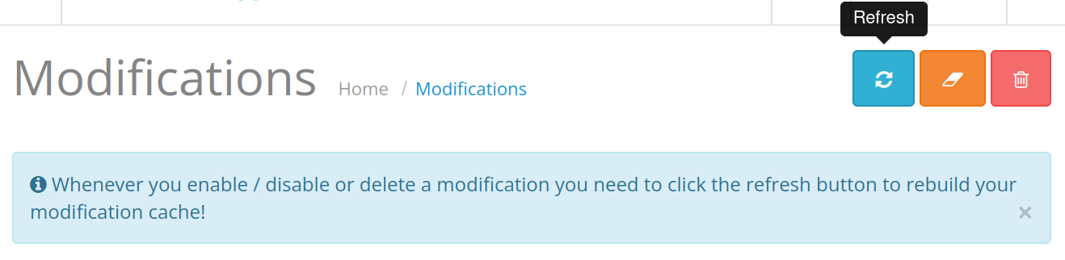
2. Then go to *Extensions >> Extensions >> Shipping*. Install the current delivery modules and specify the information required in each module. The data fields marked with a red asterisk (*) are mandatory. After entering the information at the top right, click the “Save” button.

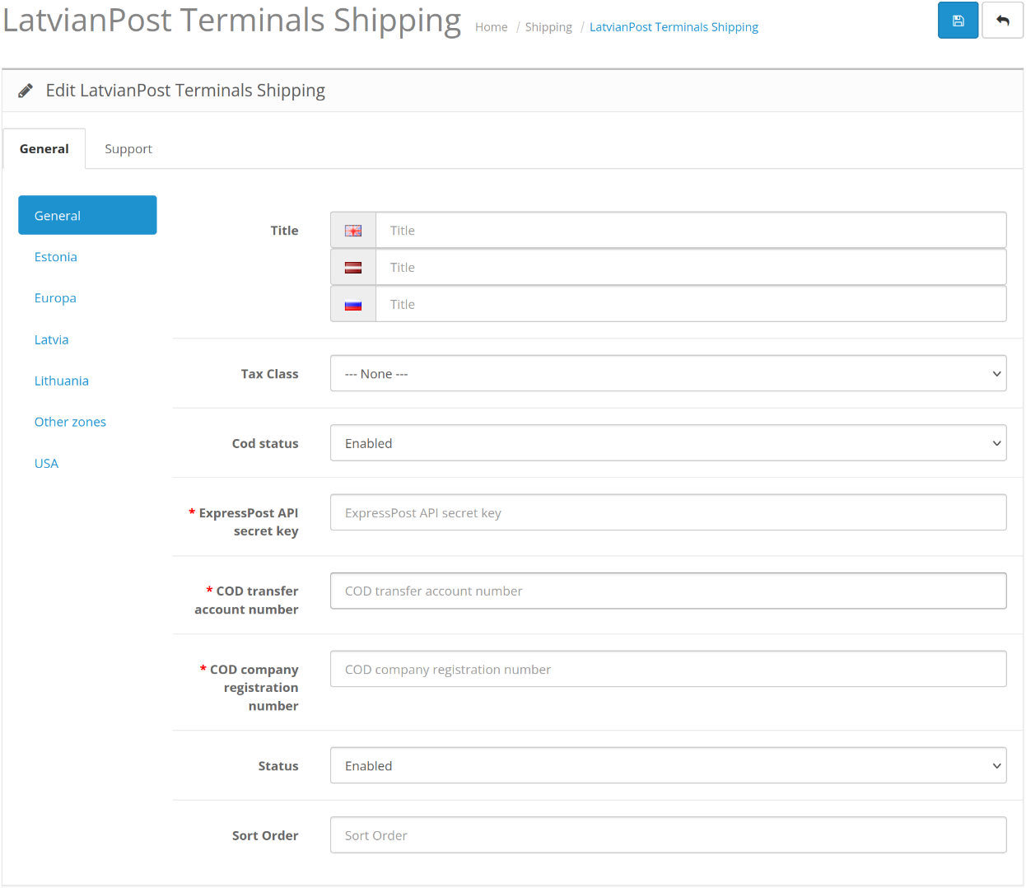

|  |  |  |
| --- | --- | --- |
| **Field name** | **Potential values** | **Field description** |
| Title | Text | Specifies the name of the delivery method as it will appear during checkout. |
| Tax class | VAT class or –None– value | Specifies whether a VAT class should be applied to the delivery price. |
| COD status | On / Off | Cash on delivery. |
| MyPost User ID | Mixed number and letter value | Mans Pasts user ID. |
| MyPost API key | Mixed number and letter value | Mans Pasts API Key. |
| ExpressPasts API secret key | Mixed number and letter value | ExpressPasts API secret key. |
| COD transfer account number | Bank account number | Bank account number for post-payment. |
| COD company registration number | Company registration number | Company registration number for post-payment. |
| HS Code (for international shipments) | Number value | HS code for international shipments. |
| Product Country of Origin (for international shipments) | Optional value | Country of origin for international shipments. |
| Test mode | On / Off | Indicates whether the module is in test or production environment. |
| Status | On / Off | Indicates whether the module is switched on or off. |
| Sort Order | Number value | Specifies the module sequence between the delivery methods in the purchase checkout page. |

1. Please ensure that the relevant details for the Geo Zones in which the module will operate are correctly specified. The available Geo zones can be modified in *System >> Localisation >> Geo Zones*. After entering the information at the top right, click the “Save” button.

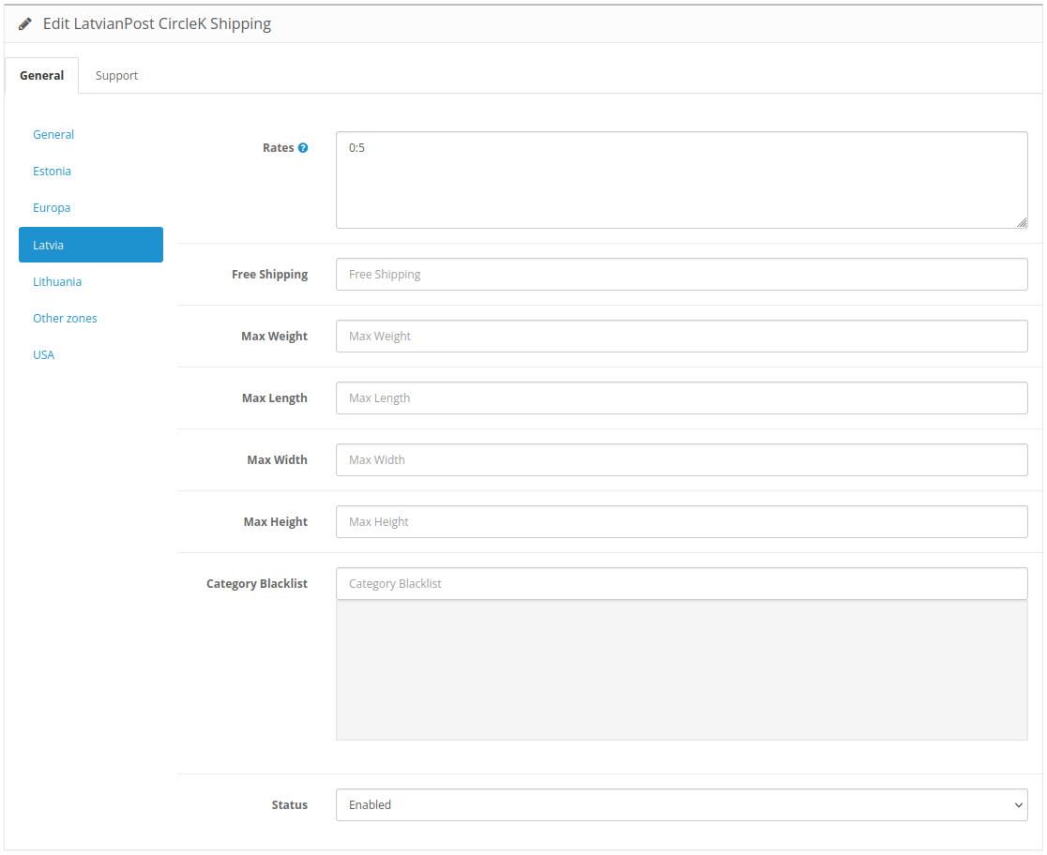

|  |  |  |
| --- | --- | --- |
| **Field name** | **Potential values** | **Field description** |
| Price | Price, for example: 0:2.99,5:4.99 | Shipping price based on weight, as displayed to the customer during delivery selection. Specify as weight:price, with values separated by commas. |
| Free Shipping | Price, for example: 20.00 | Shipping will be free for orders that meet or exceed the specified value. |
| Max Weight | Weight, for example: 20 | Specifies the maximum weight (in kilograms) allowed for the delivery option. |
| Max Length | Length, for example: 2,000 | Specifies the maximum length allowed for the delivery option. The size is indicated in mm. |
| Max Width | Width, for example: 500 | Specifies the maximum width allowed for the delivery option. The size is indicated in mm. |
| Max Height | Height, for example: 100 | Specifies the maximum height allowed for the delivery option. The size is indicated in mm. |
| Category Blacklist | Optional field | This section allows you to specify the categories for which no delivery option will be available. Accordingly, no delivery option will be offered during checkout if any of the products belong to the specified category. |
| Status | On / Off | Indicates whether supply is on or off for the respective zone. |

1. After entering the information at the top right, click the “Save” button.

# **Order Processing**

To print an order postage label, go to *Sales >> Orders* section and open the order using the eye (View) button. In the top bar, when viewing an order, click the “Print Pasts Label” button to generate the label. The parcel size should also be selected for Lithuanian and Estonian parcel locker deliveries. You can do this by using the same button and then clicking on the required size. The system will automatically download the label once the data is processed.

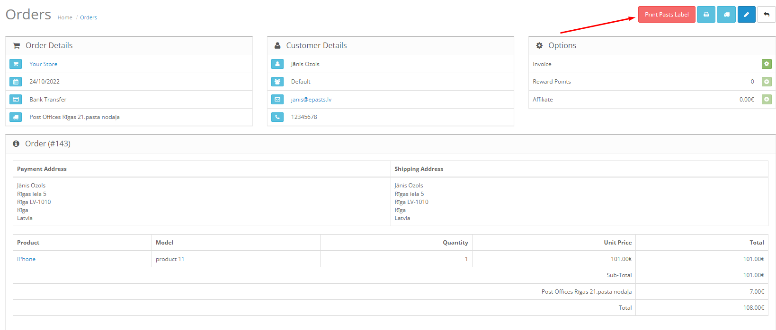

To generate order manifests, go to *Sales >> Orders*. It is important to note that order manifests can only be generated after delivery labels have been created for the respective orders.

To print the current manifests, select the relevant orders; this will activate the corresponding delivery manifest button in the top bar. Upon clicking the button, data processing will begin and the manifest will be downloaded. Only one type of delivery order manifest can be selected at a time. Accordingly, it is either ExpressPasts or MansPasts. It is not possible to select both simultaneously.

# **Courier Request**

To request a courier, go to *Extensions >> Extensions >> Modules >> Pasts Courier*. First, click the green “Install” button, if you haven’t done so already. Next, click on the pencil (Edit) or + (Add New) button to edit an existing courier request template or create a new one. You can create multiple templates if you have different package delivery addresses.



When completing the request template, you must provide the required information marked with a red asterisk (*) — Company name, phone number, city/town, district, postal code, date, and times of pickup. The optional data fields can be filled in as needed. Once the data have been specified, save the information by clicking the “Save” button. Once the data have been saved, click the “Submit Request” button to place the courier request.

