**Pasts Woocommerce Module Installation Instructions**

**Module Functionality**

* Postal delivery to post offices in Latvia and Lithuania.
* Postal delivery to parcel lockers (terminals) in Latvia, Lithuania and Estonia.
* Postal delivery by Pasts courier delivery both in Latvia and abroad.
* Letter and parcel post deliveries domestically and abroad.
* Option to print postal labels directly from the e-store administrator environment.
* Option to call a courier directly from the e-store administrator environment for handing over postal items.

# **Terms and Concepts Used**

Root directory — the main directory of the FTP client where all your website files are stored, usually www or public_html.

# **E-store Requirements**

The module is compatible with Woocommerce versions from 6.x to 9.x.

# **Server Requirements**

The module is compatible with PHP 7.4 and later versions. Before proceeding with the installation, ensure that PHP version 7.4 or later is installed on the server.

# **Pasts Module Installation and Tools Required**

If you are going to connect the Pasts module manually by copying files onto a server, you will need a tool to connect to the FTP client. To connect to the FTP client, you can use the following tools or choose another tool you are familiar with:  
FileZilla Client <https://filezilla-project.org>

WinSCP <https://winscp.net/eng/download.php>

Cyberduck <https://cyberduck.io>**Pasts Module Installation**

1. Create an empty folder and export the module files to that folder.
2. Connect to your FTP client using one of the tools specified above.
3. The ZIP file contains two Pasts modules: ExpressPasts and MansPasts. Install both modules, or only the one required, as necessary. Drag the Pasts module folders into the Wordpress project system at the following location: wp-content/plugins.

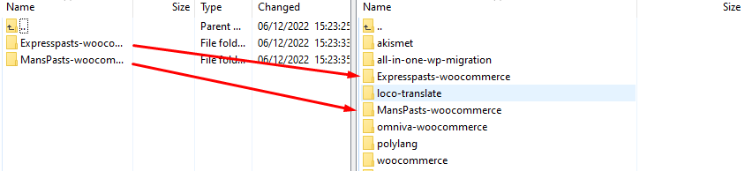

1. After adding the module successfully, it will appear among the installed plugins in *Plugins >> Installed Plugins*. After finding “ExpressPasts shipping” and “MansPasts” modules, activate them by pressing the “Activate” button.  
   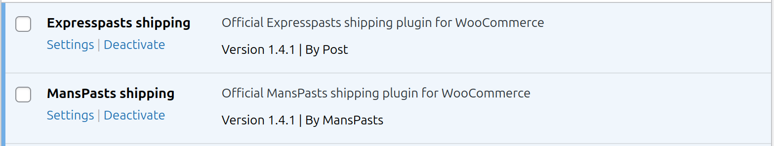
2. Once the module is activated, open *WooCommerce >> Settings*. In the opened window, click the “Shipping” tab and select the delivery method to be configured.  
   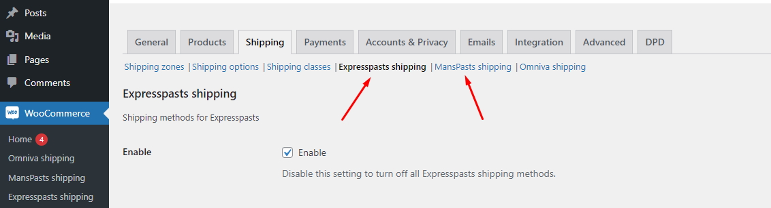
3. Enter the required information in each module.

|  |  |  |
| --- | --- | --- |
| **Field name** | **Potential values** | **Field description** |
| Enable | Options | Enable module. |
| Enable Test mode | Options | Enable test mode. |
| API user | Mixed number and letter value | API key data field. |
| API key | Mixed number and letter value | API key data field. |
| Company name | Text | Company name. |
| Bank account | Text | Bank account number. |
| Shop name | Text | E-store name. |
| Shop city | Text | The city/town where the shop is located. |
| Shop address | Text | The address of the shop. |
| Shop postcode | Text | The postal code of the shop. |
| Shop country code | Options | The country where the shop is located. |
| Shop phone number | Numeric data field | The phone number of the shop. |
| Shop email | Email data field | The email address of the shop. |
| Pick up time start | Numeric data field | The earliest time the orders can be picked up. |
| Pick up time end | Numeric data field | The latest time the order can be picked up. |
| HS code | Number value | Product HS (Harmonized System) code. |
| Country of Origin | Optional field | Country of origin of the products. |
| Price type | Optional field | Delivery price calculation method. |
| Price | Number value | Delivery price. |
| Free from | Number value | Free delivery applies from this order price. |
| Free with coupon | Optional field | Type of coupon that activates free delivery. |
| Description | Text | Delivery method description as seen by the customer. |
| Max cart weight (kg) for parcel terminal | Number value | Maximum cart weight (kg) for parcel lockers. |
| Max cart weight (kg) for post offices | Number value | Maximum cart weight (kg) for post offices. |
| Max cart size (cm) for terminal | Number value | Maximum cart size (cm) for terminals. |
| Disable for specific categories | Optional field | The categories for which no delivery method will be offered. |
| Automatic terminal selection | Options | Auto-select terminal based on provided postal code. |
| Custom label names | Text | Custom name for the delivery method (overrides default). |
| Positions | Number value | The position of the delivery method in the list at checkout. |
| Enable manifest print | Options | Enable printing the manifest. |
| Enable debug mode | Options | Enable the debugging mode. |

# **Setting Up Courier Methods**

1. To set up Pasts courier delivery (Express Pasts) or Pasts standard delivery (Mans Pasts), the corresponding plugin must be installed and activated.
2. Next, go to *WooCommerce >> Settings*, then open the “Shipping” tab and click on “Shipping zones”.
3. In this section, locate the delivery zone where you want to enable the courier method. Click the “Edit” button on it.
   1. If the required zone is not visible in the list, it can be created using the “Add zone” button. Then enter the zone name and select the relevant countries under “Zone regions”. If no countries are selected, the delivery will be possible to all regions.
4. In the “Shipping methods” field, find the relevant courier delivery method: “Pasts courier delivery” or “Pasts standard delivery”. If it is not in the list, add it using the “Add shipping method” button.
   1. If the input field “Title” is empty or has the default value “Pasts courier delivery” or “Pasts standard delivery”, it will also be translated into Latvian, Lithuanian and Estonian. If the input field has a different value, it is not translated.
   2. If only one number is entered in the “Cost” input field, there will be only one price for any weight. The price can also be entered based on the weight. In the sample image, 2.5 is kg and the value 3 is the price in EUR, the entry is made with : (colon), connecting the two parameters and separating the next weight/price parameter by a comma with no spaces. If the price is 0 or the field is empty, the delivery will be free of charge.
   3. In the input field “Free from”, you can specify the purchase amount at which delivery will become free of charge.
   4. For Pasts standard delivery, the package type should be selected in the “Item type - Postage type” field.
5. If needed, proceed to step 3 to enable the courier for an additional delivery zone.

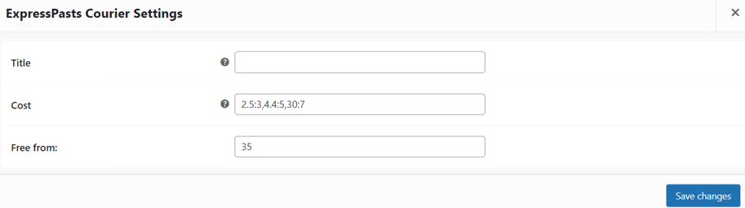

# **Order Processing**

To print a delivery label for the order, open *WooCommerce >> MansPasts shipping* or *WooCommerce >> ExpressPasts shipping*. The section to be opened depends on the delivery method used for the order.

**MansPasts orders**  
In *WooCommerce >> MansPasts shipping*, you can view all orders placed using the MansPasts courier delivery method.

To generate a label for an order, click the “Print” button, and the delivery label will be generated.

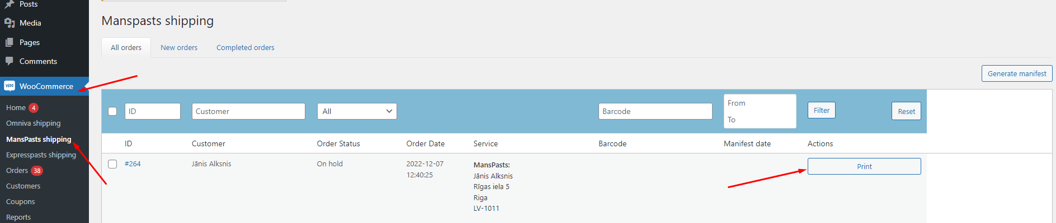

To create the delivery manifest, select the orders and click the “Generate manifest” button.

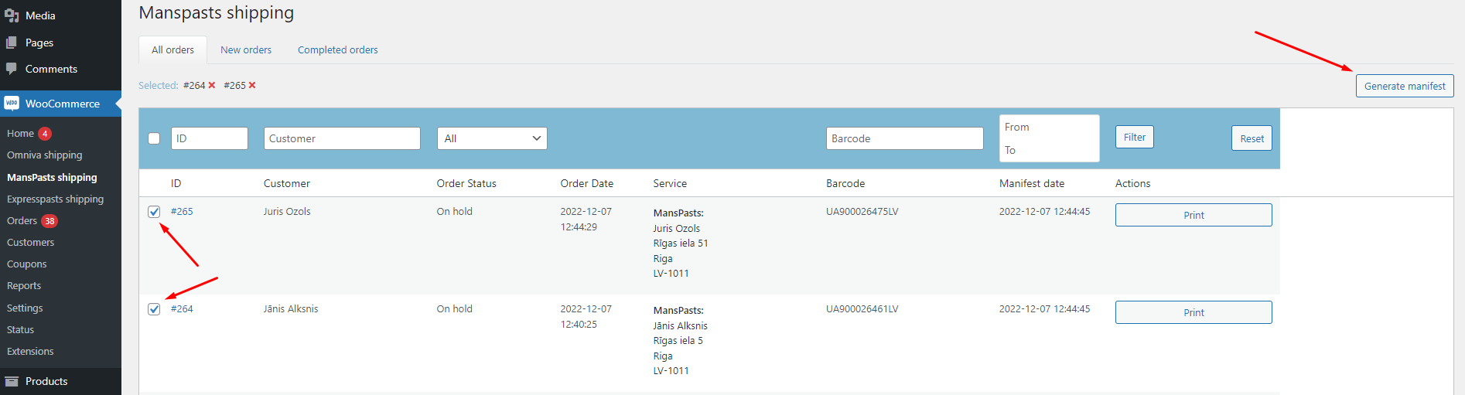

**ExpressPasts** **orders**

In *WooCommerce >> ExpressPasts shipping*, you can view all orders placed using the following delivery methods: "Parcel terminal", "Post offices", "Pasts courier delivery".

To generate a label for an order, click the “Print label” button, and the delivery label will be generated. For Lithuanian parcel terminals, the package size should be selected first. This can be done by completing the input field in the “Box size” column.

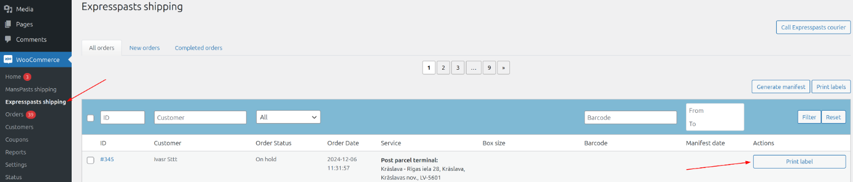

To create the delivery manifest, select the orders and click the “Generate manifest” button.

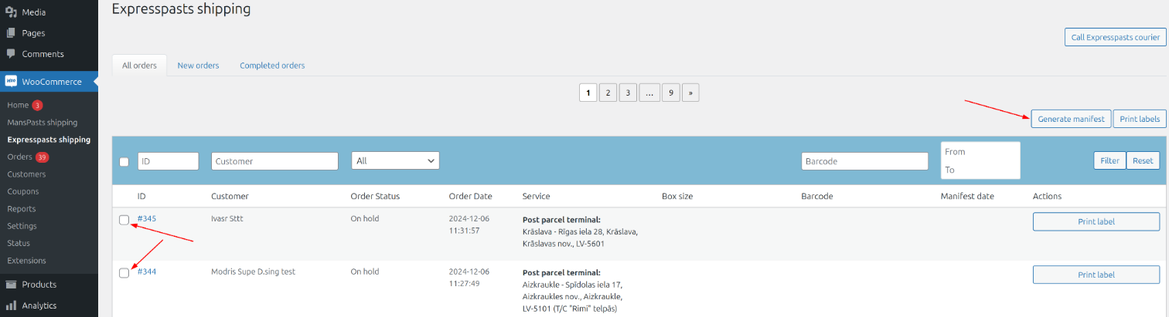

To request a courier for order pickup, select the current orders and click the “Call Post courier” button. Then, click the “Call post courier” button in the modal again.

