# **Shopify Pasts Delivery App: Installation and Configuration Manual**

# **App functionality**

* Shipment processing and delivery to post offices of Pasts (Latvian Post) and Lietuvos Paštas (Lithuanian Post).
* Shipment processing and delivery to parcel terminals of Pasts and Unisend in Estonia and Lithuania.
* Shipment delivery via Express Pasts courier service, both within Latvia and internationally.
* Letter and parcel deliveries domestically and internationally.
* Option to print shipment labels and manifests directly from the e-store environment.
* Option to order a courier directly from the e-store environment to deliver shipments.

**Shopify store requirements**

The App is compatible with all Shopify pricing plans.

Limitations. Without the *Carrier Calculated Shipping* feature — which is not included in the Shopify Basic and Shopify pricing plans — the App will not display part of delivery settings. Unavailable settings will be hidden. However, some of these can still be configured within Shopify's native shipping settings, outside the App interface.

If you require access to all the shipping settings offered by the App and your Shopify Store is on the Basic or Shopify plan, you will need to contact Shopify Support directly and request the activation of the *Carrier Calculated Shipping* feature. Shopify will charge an additional monthly fee for this service.

Note. Without the *Carrier Service Shipping* feature, Shopify Store customers will not be able to select delivery to Lithuanian Post offices.

Without the *Carrier Service Shipping feature*, customers can bypass the delivery method selector in the *CART*. To load these purchases into the App, Shopify’s delivery methods in the settings must be linked to the App's delivery options.

Another issue is that without the *Carrier Service Shipping* feature, when one of the Pasts delivery methods is selected in the *CART*, other delivery methods may also be available for selection at *CHECKOUT*. Even when other delivery methods are selected in the *CART*, Pasts delivery option will also appear at *CHECKOUT*. Both issues will be addressed in the future, when the App is launched in the Shopify App Store.

# **Pasts App installation**

1. Contact Pasts by sending an email to [uznemumiem@pasts.lv](mailto:uznemumiem@pasts.lv), indicating: for Shopify Store connection (you must send the Shopify Store URL that contains “myshopify.com”).

Note: *To access the services provided by the App and use the App key, you must have a valid service agreement with Latvian Post.*

1. In the reply, you will receive the App installation URL (valid for 7 days). Enter the provided URL address into your browser.
2. If the correct URL is entered, you will be directed to Shopify. Choose your Store and click the "Install" button.

The App settings will appear in the Store admin panel. If they do not appear, simply type "Pasts" in the Search field at the top to access them. The module can also be opened by clicking *Settings >> Apps and sales channels >> Pasts Shipping >> … >> Open app*. To simplify access to the module, click the button with the pin symbol ("Pin to your navigation") in the left-hand navigation.

1. Click the "Authenticate" button to connect the App to your Shopify Store. If Store data such as location, currency, email or phone number is changed later, you can update the values ​​used in the App by clicking the "Authenticate" button again.

1. If the Shopify Store has the *Carrier Calculated Shipping* feature enabled, select "Yes" for "Use Carrier Service", otherwise select "No". The switch shows the current selection.

a. If the Store has *Carrier Calculated Shipping* enabled, enter the number of closest locations to display to the customer in the “Location count” field. The number of locations can be set between 1 and 20. The closest locations are determined based on the shopper's address entered during checkout.

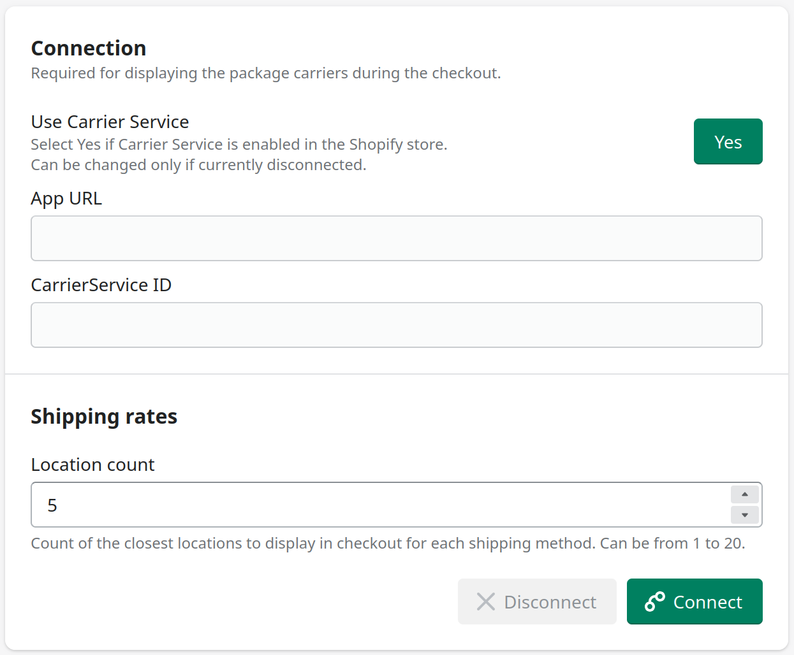

Then click the "Connect" button. Both fields — "App URL" and "CarrierService ID" — will be filled in automatically. If either field is empty, *Carrier Calculated Shipping* feature might not be available for the Store.

The next step is to verify that the shipping methods have been correctly added. To do this, go to *Settings >> Shipping and delivery >> Shipping >> General shipping >> Manage*.

In the "*Shipping zones*" section, under each zone, you should see "Pasts" (Rates provided by app)". It may be listed under "*Carrier and app rates*".

1. If the Store does not have *Carrier Calculated Shipping* feature, you will need to create "Shipping rates" for Pasts delivery methods. This can be done in *Settings >> Shipping and delivery >> Shipping >> General shipping >> Manage*.

To capture purchases in your App that bypassed the shipping method selector in your *CART*, you need to link the shipping methods in your Shopify settings to the App's shipping methods. It is important not to link the same Shopify shipping method more than once.

Then click the "Connect" button.

In the Shopify Store theme, you need to remove the product buttons that allow you to immediately add the product to the *CART* and open the *CHECKOUT*. Otherwise, the shipping method selector in the cart will be bypassed.

To remove these buttons, go to *Online Store* >> for the active theme (marked Current theme), click *Customize.* Then select the page to edit at the top and move "Home page" to *Products* >> *Default product*. Then select the "*Product information*" block on the left, where you will find the "Buy buttons" option. The available settings will appear on the right. Turn off "Show dynamic checkout buttons".

After adding a product to the *CART*, a pop-up notification may appear, featuring a button that allows customers to proceed directly to *CHECKOUT*. To remove it, open the *Online Store >> active theme (marked Current theme) and click "..." >> Edit code*. Then locate the correct file (for example, "cart-notifcation.liquid"), which may vary depending on the theme. Locate the button code within it and either remove it or comment it out. Then click "Save".

After that, it is recommended to verify that the shipping method selector is visible in the CART once a product has been added.

If it is not visible or appears in a wrong location, you should add the text from the "Shipping location selector" to your Store theme. To do this, navigate to *Online Store >> the active theme (marked Current theme) and click "..." >> Edit code*. In the code editor, find the correct “main-cart.liquid” or similar file and open it. Then copy the above text, preferably above the checkout button, and click the "Save" button.

1. Enter the information required for the App. You need to enter the MansPasts Client ID and API key, or the ExpressPasts API key (*please contact Pasts Support to add Store IP address to ExpressPasts, or you can do it yourself on the Self Service Portal -* [*https://express.pasts.lv/*](https://express.pasts.lv/)). To create international shipments outside the European Union, you need to enter the main HS code and country of origin. After entering this information at the bottom or top, click the "Save" button located on the right.

|  |  |  |
| --- | --- | --- |
| **Field name** | **Possible values** | **Field description** |
| MansPasts API ID | Mixed number and letter value | API user ID. |
| MansPasts API key | Mixed number and letter value | API Key. |
| ExpressPasts API secret | Mixed number and letter value | Express Pasts API secret API Key. |
| Default HS code | Number value | Default HS code for international shipments. |
| Default origin country code | Text | Default country of origin two-letter abbreviation (ISO 3166-2) for international shipments. |

If you have an Advanced Shopify or Shopify Plus plan, you can obtain the HS code and country of origin for each product. You should set the HS code and country of origin for the product in *Products >> selected product >> Shipping by checking "Include customs information for international shipping"* and then filling in the "Harmonized System (HS) code" and "Country/Region of origin" fields.

1. Provide the required information for each shipping method you want to use. You can do this by opening the appropriate shipping method in the module navigation on the left.

In the absence of the *Carrier Calculated Service* feature, most of these fields are not available. In this case, you can edit the delivery methods by navigating to *Settings >> Shipping and delivery >> Shipping >> General shipping >> Manage* and changing the options available there. Without *Carrier Calculated Service*, only the "Delivery method status" and "Use test API fields" options will be available in the App.

Data fields marked with a red asterisk (*) are mandatory.

Regions can be added or deleted. For a delivery method to be available to customers, it must have at least one region with a price greater than 0. Region names can include cities, counties or countries (ISO 3166-2 abbreviation, or name in English, Latvian or Russian).

The "default" region includes all countries not listed under regions. For example, to enable the method for only one region, set the "default" price to 0 and add a new region with a price greater than 0.

Then click the "Save" button at either the bottom or top right.

|  |  |  |
| --- | --- | --- |
| **Field name** | **Possible values** | **Field description** |
| Delivery method status | On / Off | Indicates whether the module is switched on or off. |
| Use test API | On / Off | Indicates whether the module is in test or production environment. |
| Require customer phone number | Yes / No | Indicates whether the module will ask the customer to enter their phone number. |
| Name | Text | Name of delivery method visible to the customer. Only the default name is translated into Latvian or Russian. |
| Description | Text | Delivery method or instructions visible to the customer. Only the default description is translated into Latvian or Russian. |
| Free from | Price | If this value is less than the total purchase price, then delivery with this method is free of charge. An empty field indicates that delivery is always against payment, and 0 - that it is always free of charge. |
| Region name | Text | Name of delivery region used to search for the customer’s region. |
| Region price | Price | Delivery price that is shown to the customer. 0 indicates that the region is excluded, and the delivery method will not be used if the customer’s address is in this region. |
| Region min delivery days | Number value | Minimum delivery term in business days. Required if the maximum delivery time has been entered. |
| Region max delivery days | Number value | Average delivery term in business days. Required if the minimum delivery time has been entered. |

# **Pasts App update**

If the App is already installed, but there are issues with its operation or if the settings have not been reviewed for some time, it is recommended to review them again.

1. In the App’s main settings, click the "Authenticate" and "Connect" buttons again.

2. Review and update the App's delivery method settings.

3. If the first two steps do not resolve the issue, review the Pasts module installation steps above, starting from Step 4.

4. If this does not work either, please contact the Pasts support service.

# **Order processing**

To see your orders, go to the "Orders" section in your Shopify Store admin panel.

Purchases are not automatically added to the App's shopping list. To sync your App's shopping list with your Shopify orders, click the "Get orders" button.

To create a package, click the "View" button, then select "New package".

The input fields for creating a package depend on the delivery method chosen by the Store customer. Once all required fields are filled in, click the "Create" button.

|  |  |  |
| --- | --- | --- |
| **Field name** | **Possible values** | **Field description** |
| Item type | Optional field | Visible if the purchase is a Mans Pasts courier purchase. |
| Postage type | Optional field | Visible if the purchase is a Mans Pasts courier purchase. Selection possible if the "Item type" is "Letter". |
| Insurance | Number value | Visible if the purchase is a Mans Pasts courier purchase and the "Postage type" is "Insured". |
| Priority | Optional field | Visible if the purchase is a domestic Express Pasts purchase. |
| Size | Optional field | Visible if the purchase is delivered to a Lithuanian Post Office package terminal. |
| Package weight | Number value | Package weight in grammes. If this is left blank, the package weight will default to the total weight of the products in the order. |

Once the package is successfully created, it will appear at the bottom of the order details. To print a shipping label for the package, click the "Sticker" button.

# **Manifests**

To create a new manifest, go to the "Manifest" section. This section may only be visible after clicking "View more".

Then, click the "New manifest" button, which will open a pop-up window.

To add purchases to the manifest, click on the "Orders" field. A list of purchases will appear, allowing you to select the ones to be added. You can filter purchases by order number, entering it in the provided input field.

Only orders with Pasts courier delivery or Pasts standard delivery can be included in the same manifest.

Pasts courier delivery orders are delivered to post offices or Pasts parcel lockers in Latvia, or by Pasts courier delivery.

A manifest can only be created once for Pasts standard delivery parcels. Therefore, before creating a manifest, make sure that all necessary parcels are attached to the respective purchases.

Pasts courier delivery orders can be included in multiple manifests. If necessary, check the option "Include orders which already have a manifest". When all orders to be included in the manifest are selected, click the "Create" button.

Once the manifest is successfully created, it will be added to the manifest list and automatically opened. To view the manifest again, click the "View" button next to it.

# **Courier request**

To request a courier for order delivery, go to the “Request courier” section and click the "New courier request" button. Input field default values are automatically populated from the first Shopify Store location found. This can be changed in the *Settings >> Locations section*.

Data fields marked with a red asterisk (*) are mandatory to create a courier request.

|  |  |  |
| --- | --- | --- |
| **Field name** | **Possible values** | **Field description** |
| Company name or first name and last name | Text | Company name or first name and last name. |
| Phone number | Text | Phone number which will be used to communicate with the courier. |
| Email | Text | E-mail. |
| Comments | Text | Comments. Additional information required for a courier request. |
| Date | Date (year-month-day) | The date on which the courier is required.  The default value is the current date. |
| Time from | Time  (hour:minute) | The time from which the courier may arrive. The minimum value is 9:00, and it must be at least one hour after the request time. |
| Time to | Time  (hour:minute) | The time until which the courier may arrive. The maximum value is 18:00, and it must be at least one hour after the "Time from". |
| Transport type | Options | Van or lorry. |
| Manifests | Options | Manifests to include in the courier request. All shipments included in the selected manifests will be added. Only Express Pasts manifests can be added. |
| Total package size | Number value | Total size of packages in cubic metres. |
| Available loading area | Number value | Length of available loading area in metres. |
| Total weight | Number value | Total package weight in kilogrammes. |
| City | Text | Address city. Required if the address region has not been entered. |
| Area | Text | Address region. Required if the address city has not been entered. |
| District | Text | Address area. |
| Village | Text | Address village. |
| Street | Text | Address street. |
| House | Text | Address house number or name. |
| Apartment number | Text | Address apartment/flat number. |
| Zipcode | Text | Address zipcode/postcode. |

Once the courier request has been successfully created, it will appear in the courier request list. To view the details of the request, click the "View" button. Requests can also be viewed by visiting <https://express.pasts.lv/lv/courier_requests> in your browser and logging in.

